

C05 AT3
Name: K. Archana Reg No: 192524209
Course : Computer Vision Code: DSA0204

1. Reading, Processing, and Displaying Multiple Images from a Folder
In Computer Vision, images are the input data. OpenCV provides functions to read, process, and display images efficiently.
Basic Pipeline
Image Folder → Read Images → Validate → Preprocess → Analyze → Display/Save
Step 1: Read images
import cv2
import glob

files = glob.glob("images/*.jpg")

for file in files:
img = cv2.imread(file)

if img is None:
print("Error:", file)
continue

# Resize
img = cv2.resize(img, (640, 480))

# Convert to grayscale
gray = cv2.cvtColor(img, cv2.COLOR_BGR2GRAY)

cv2.imshow("Image", gray)

if cv2.waitKey(500) == 27:
break

cv2.destroyAllWindows()
Important OpenCV functions
- cv2.imread() – reads an image.
- cv2.resize() – changes image dimensions.
- cv2.cvtColor() – converts BGR to grayscale or other color spaces.
- cv2.imshow() – displays an image.
- cv2.waitKey() – controls display time.
- cv2.imwrite() – saves processed images.
- cv2.destroyAllWindows() – closes windows.
Why this design is efficient
- Process one image at a time to reduce memory usage.
- Resize large images to reduce processing time.
- Convert to grayscale when color is not required.
- Check for invalid images before processing.
- Filter image extensions to avoid unnecessary files.
Challenges
- Incorrect folder path
- Corrupted images
- Different image sizes
- Unsupported formats
- Large image files
- High memory usage
Optimizations
For large datasets, use:
File filtering → Resize → Preprocessing → Computer Vision algorithm → Save result
For example, after preprocessing, an application could perform edge detection, object detection, face detection, or segmentation.

2. Debugging a Video File That Is Not Loading in OpenCV
In Computer Vision, video is processed as a sequence of frames.
Video Pipeline
Video File → VideoCapture → Frame Reading → Processing → Display
Step 1: Check file path
import os

path = "video.mp4"

if not os.path.exists(path):
print("File does not exist")
If the path is incorrect, OpenCV cannot load the video.
Step 2: Open the video
import cv2

cap = cv2.VideoCapture("video.mp4")

if not cap.isOpened():
print("Video cannot be opened")
isOpened() verifies whether OpenCV successfully opened the video source.
Step 3: Read frames
ret, frame = cap.read()

if ret:
print("Frame successfully read")
else:
print("Frame cannot be read")
- ret = True → frame is available.
- ret = False → frame could not be obtained.
Step 4: Check video properties
print("Width:", cap.get(cv2.CAP_PROP_FRAME_WIDTH))
print("Height:", cap.get(cv2.CAP_PROP_FRAME_HEIGHT))
print("FPS:", cap.get(cv2.CAP_PROP_FPS))
print("Frames:", cap.get(cv2.CAP_PROP_FRAME_COUNT))
These values help identify problems with the video.
Step 5: Test another video
If another video works:
Problem → Original video/codec
If no video works:
Problem → OpenCV installation/backend/system configuration
Step 6: Check codec and format
Some videos may use codecs that the installed OpenCV video backend cannot decode properly.
Possible solution:
- Convert the video to a supported format.
- Check the installed OpenCV version.
- Check the video codec.
- Try another video file.
Complete debugging program
import cv2
import os

path = "video.mp4"

if not os.path.exists(path):
print("Video file not found")
exit()

cap = cv2.VideoCapture(path)

if not cap.isOpened():
print("Cannot open video")
exit()

while True:
ret, frame = cap.read()

if not ret:
print("Cannot read frame or video ended")
break

cv2.imshow("Video", frame)

if cv2.waitKey(25) & 0xFF == ord('q'):
break

cap.release()
cv2.destroyAllWindows()
Common causes
Problem | Possible solution
Wrong path | Check file location
Corrupted video | Try another video
Unsupported codec | Convert video
isOpened() false | Check OpenCV/backend
No frames | Check video properties
Poor performance | Reduce resolution/FPS

3. Overlaying Text and Shapes on Live Video
This is a common Computer Vision visualization technique used to show detection results, coordinates, labels, and tracking information.
Pipeline
Camera → Capture Frame → Process Frame → Draw Overlay → Display → Repeat
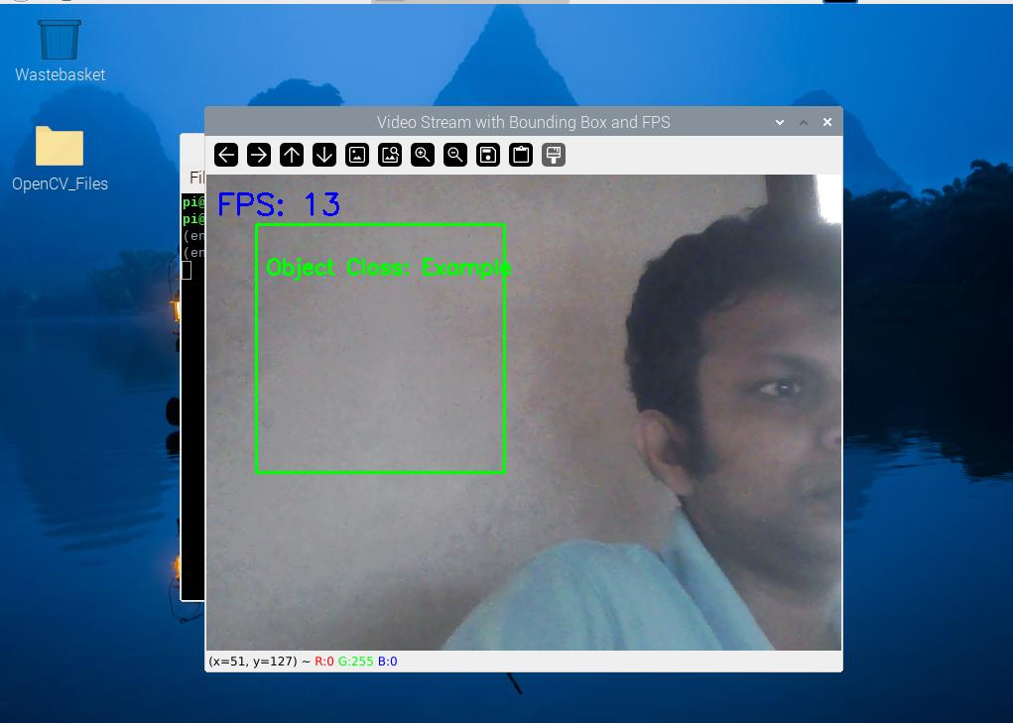
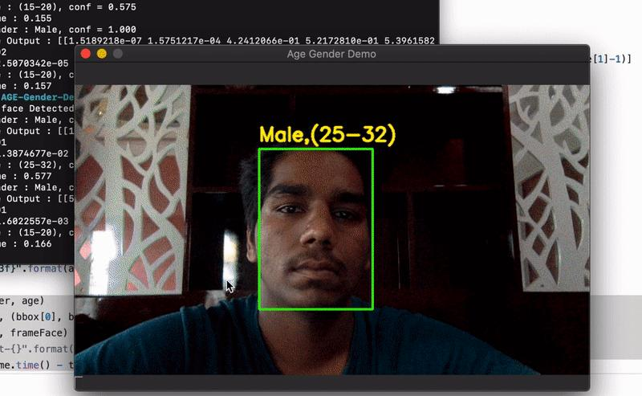
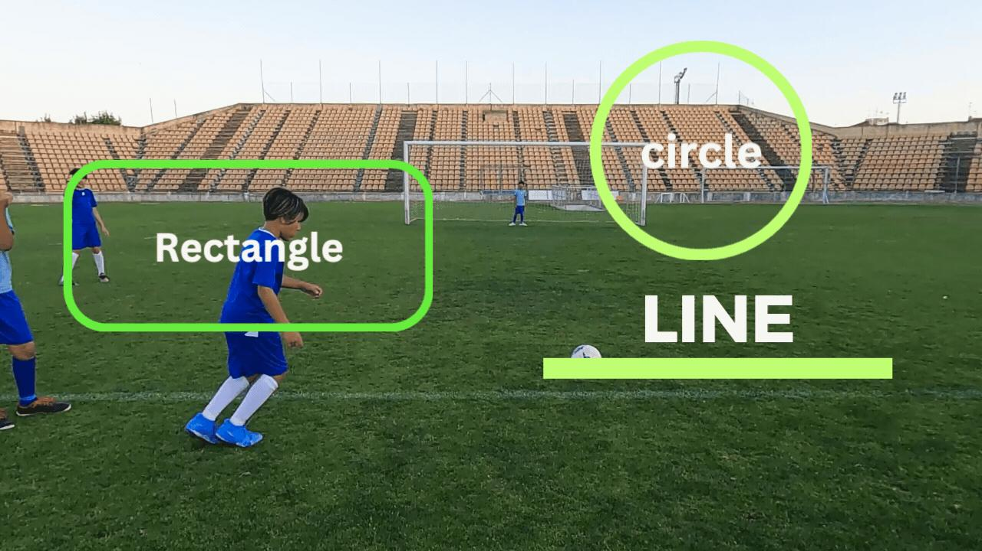
5
Important functions
Rectangle
cv2.rectangle(frame, (50, 50), (300, 200), (0, 255, 0), 2)
Used for:
- Object detection bounding boxes
- Face detection
- Region of interest
Circle
cv2.circle(frame, (400, 150), 50, (255, 0, 0), 2)
Useful for marking points or detected objects.
Line
cv2.line(frame, (50, 300), (500, 300), (0, 0, 255), 2)
Useful for showing paths, boundaries, or reference lines.
Text
cv2.putText(
frame,
"Person",
(50, 40),
cv2.FONT_HERSHEY_SIMPLEX,
1,
(255, 255, 255),
2
)
Used to display:
- Object labels
- Confidence scores
- FPS
- Coordinates
- System status
Complete example
import cv2

cap = cv2.VideoCapture(0)

if not cap.isOpened():
print("Camera not available")
exit()

while True:

ret, frame = cap.read()

if not ret:
break

# Draw bounding box
cv2.rectangle(frame, (50, 80), (300, 250), (0, 255, 0), 2)

# Draw circle
cv2.circle(frame, (450, 150), 50, (255, 0, 0), 2)

# Draw line
cv2.line(frame, (50, 300), (550, 300), (0, 0, 255), 2)

# Add text
cv2.putText(
frame,
"Object Detected",
(50, 50),
cv2.FONT_HERSHEY_SIMPLEX,
1,
(255, 255, 255),
2
)

cv2.imshow("Computer Vision", frame)

if cv2.waitKey(1) & 0xFF == ord('q'):
break

cap.release()
cv2.destroyAllWindows()
Efficiency in Computer Vision
For real-time performance:
- Resize frames to an appropriate resolution.
- Avoid unnecessary image copies.
- Use cv2.waitKey(1) for fast display.
- Perform expensive algorithms only when necessary.
- Process frames at an appropriate FPS.
- Release camera and window resources properly.
Overall Computer Vision Pipeline
CAMERA / VIDEO
↓
FRAME CAPTURE
↓
PREPROCESSING
(Resize / Gray / Blur)
↓
COMPUTER VISION TASK
(Detection / Tracking / etc.)
↓
VISUALIZATION
(Text / Box / Circle / Line)
↓
DISPLAY
↓
REPEAT
Key conclusion
The main concept of OpenCV pipeline thinking is to treat every Computer Vision application as a sequence:
Input → Acquisition → Preprocessing → Processing → Visualization → Output
This makes the system easier to debug, optimize, maintain, and extend.

